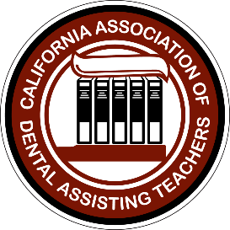 | California Association of Dental Assisting Teachers (CADAT)  Volunteer Leadership Application 2024

Thank you for your interest in serving as a volunteer for the California Association of Dental Assisting Teachers (CADAT). Submit your application to president@cadat.org. Please include your CV or resume, not to exceed two pages.
(Note: you must be a current member of CADAT to apply to volunteer.)
Please check all appropriate boxes:
□ I am submitting a new application and CV
□ I have served as a CADAT volunteer before, please provide details of prior service:
__________________________________________________________________________________________________

Full Name:
Home Address:
City/Zip Code:
Home phone: | Cell Phone:
Work phone: Extension:
Primary email: | Secondary email:

Place of Employment:
Work Address:
City/Zip Code:
Current Position: | Years Teaching:

Volunteer Leadership Competencies
Using the competencies below, indicate areas of experience or strength you believe you possess. (Please check all appropriate boxes)
□ Participation in a collaborative decision making process; influence and support changes; exhibit openness to alternative viewpoints
□ Participation in formal ethics programs
□ Leadership training work
□ Participation in membership drive projects
□ Formal business or management training
□ Expertise in marketing programs or survey projects
□ Knowledge of parliamentary procedures/Robert’s Rules of Order
□ Experience with meeting or event planning/logistics
□ Strong verbal/presentation communication skills
□ Experience serving on councils or committees, community service, school/institutional workgroups

Please answer the following questions (Use additional pages if necessary):
- How long have you been a member of CADAT?
- What contributions have you made to CADAT?
- In a few words, explain your desire to serve with CADAT?
- What contributions have you made to your profession and your classroom?
- Explain what diversity means to you, and how you would bring to CADAT?
- What contributions have you brought to your community?
- What are the significant experiences that have furthered your leadership abilities and professional growth, and why?
- What ideas, concepts or projects would you bring to a volunteer leadership position?

I certify, by signing below, that I have and will provide information throughout the selection process, including on this application, for a leadership position with CADAT that is true, correct and complete to the best of my knowledge. I understand that the information on my application will be verified by CADAT. I further understand that misrepresentation or omissions may be cause for my immediate rejection as an officer candidate.

Candidate Signature: Date:

